Name:

Clocks

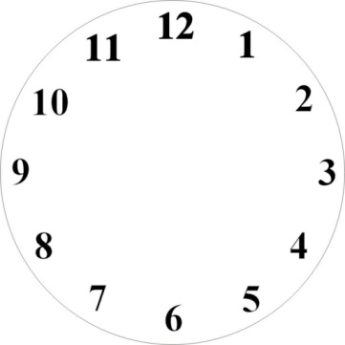Using arrows that are under the **Insert** ribbon and shapes make the analog clocks match the digital clocks.

6:30





2:000



1. 

4:450

10:150