Name:

Clocks

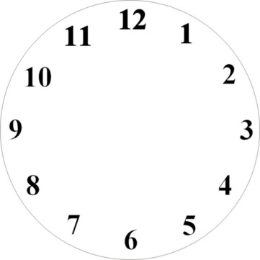Using arrows that are under the **Insert** ribbon and shapes make the analog clocks match the digital clocks.

1:30





7:000



1. 

3:450

9:150







12:30



10:00





11:45





6:15

2. 

8:25